* **Backend**

|  |  |
| --- | --- |
| *Get by ID* | *Update* |

*Bỏ qua validate ở backend*

* **Frontend**

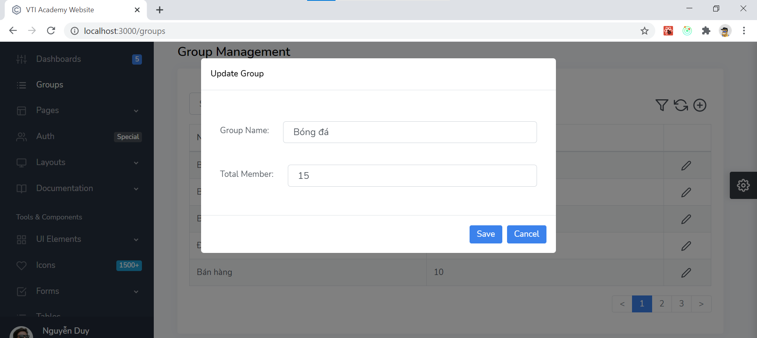

* + Add action buttons
    - <https://codesandbox.io/embed/0o8vwr8r00>
    - <https://react-bootstrap-table.github.io/react-bootstrap-table2/storybook/?selectedKind=Work%20on%20Columns&selectedStory=Column%20Formatter%20with%20Custom%20Data&full=0&addons=1&stories=1&panelRight=0&addonPanel=storybook%2Factions%2Factions-panel>
  + Chỉnh width của column

<https://github.com/react-bootstrap-table/react-bootstrap-table2/issues/226>

* **Reference**